#2016413008 (Rally) #2016413013 (Obedience & Conformation #1)

#2016413014 (Obedience & Conformation #2)
ENTRIES CLOSE: 12:00 NOON, WEDNESDAY, June 1, 2016

AT SHOW SUPERINTENDENT'S OFFICE

after which time entries cannot be accepted, cancelled or substituted EXCEPT as provided for in

Chapter 11, Section 6 of the Dog Show Rules.

PREMIUM LIST

Twenty-Fifth & Twenty-Sixth Independent Specialty Shows,

Rally Trial & 2 Obedience Trials
(Unbenched - Indoors)

Show Hours 7:00 AM - 9:00 PM

MAYFLOWER PEMBROKE

WELSH CORGI CLUB, INC.
(Licensed by the American Kennel Club)
(Member of the PWCCA)

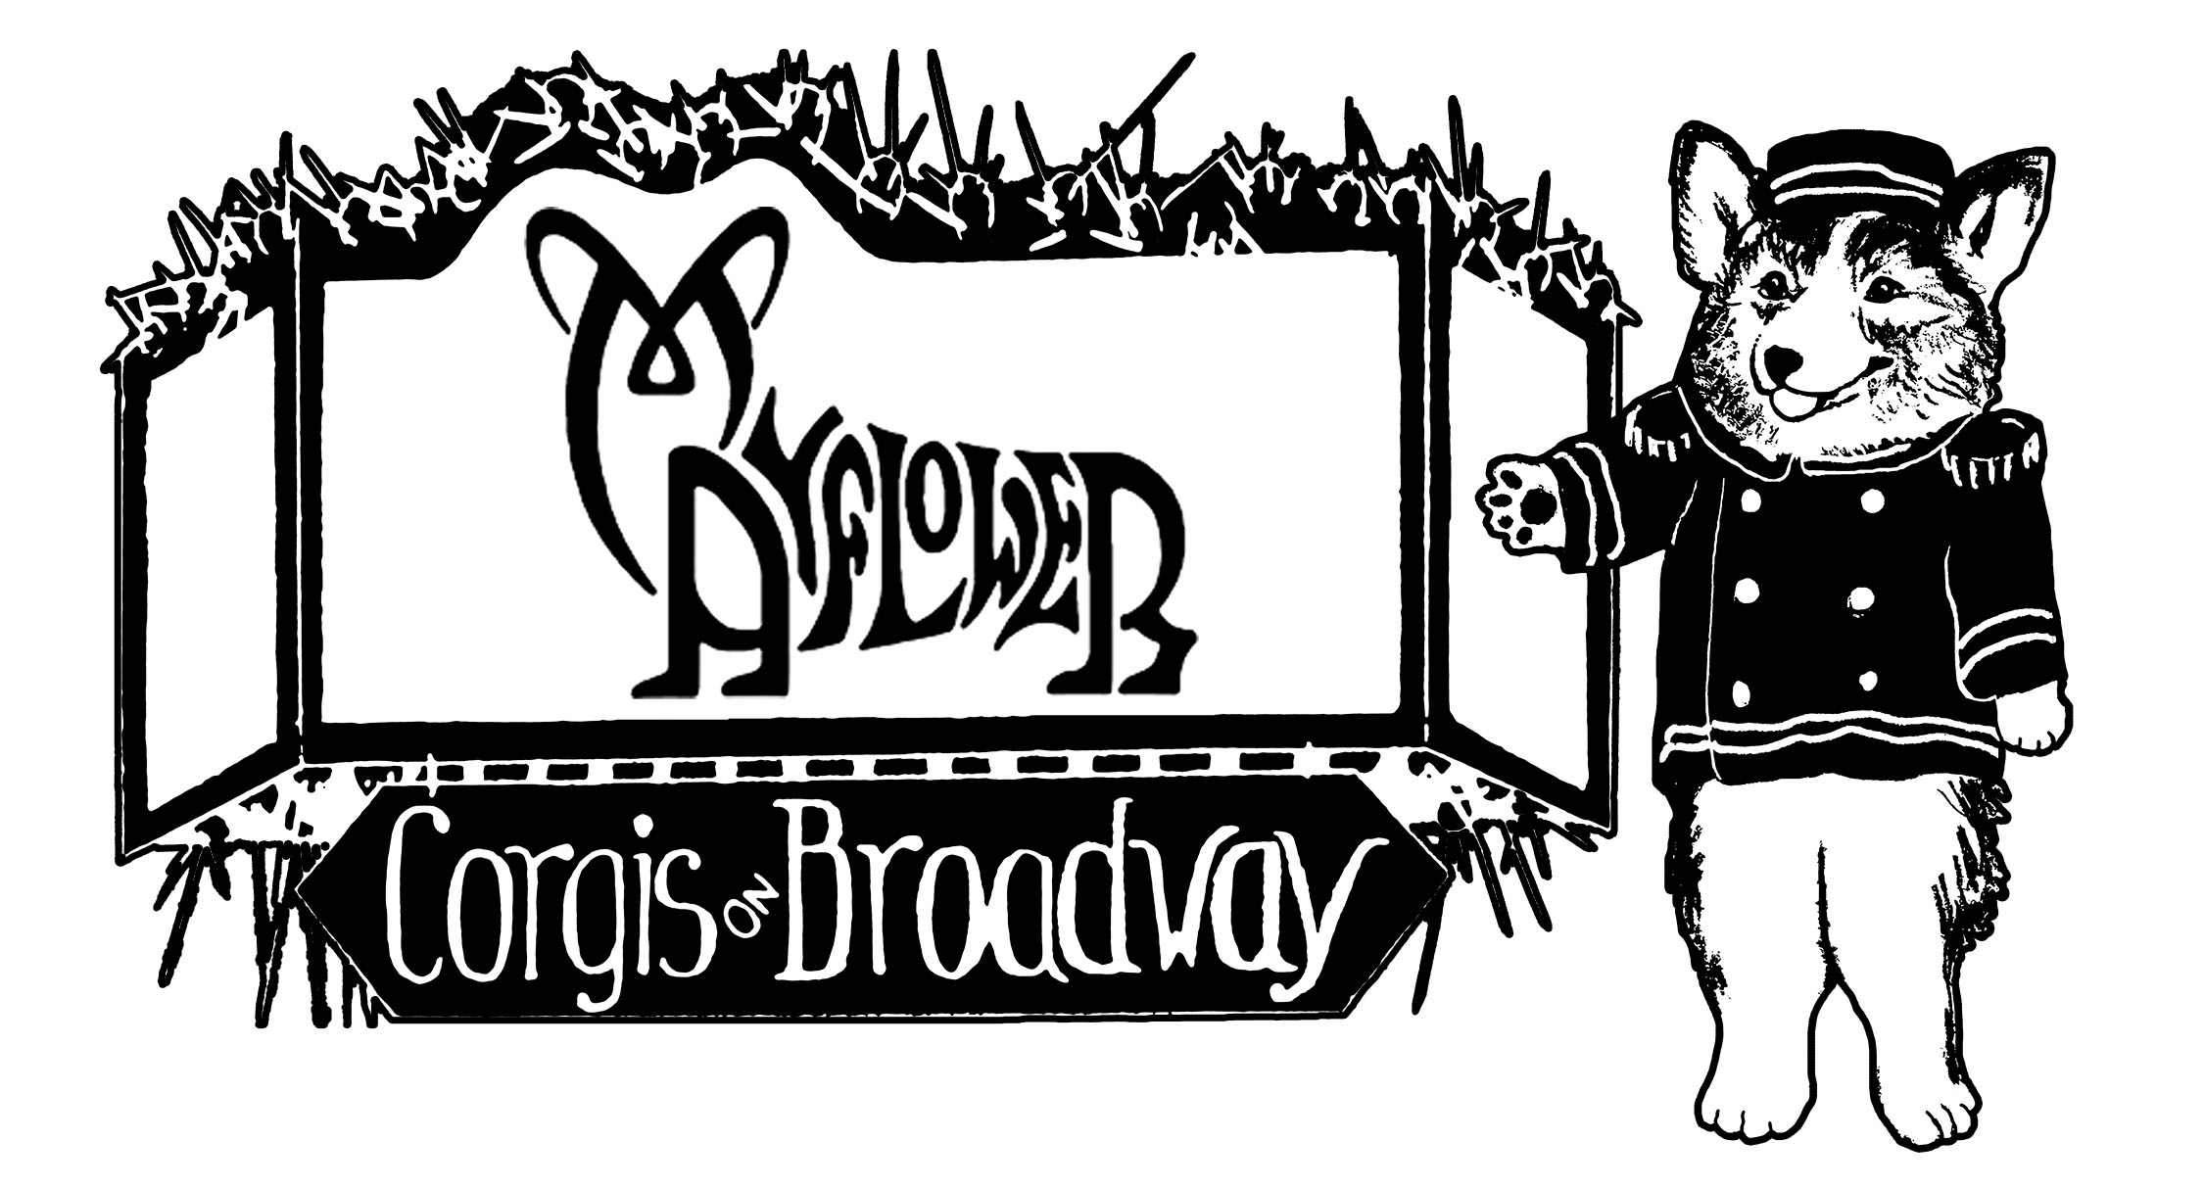

Holiday Inn Boxborough

242 Adams Place, Boxborough, MA 01719

WEDNESDAY, JUNE 15, 2016

Herding Instinct Test, Rally Trial, Veteran Sweepstakes,&

Special Attraction: Altered Dog Classes
THURSDAY, JUNE 16, 2016
Obedience Trial #1, Sweepstakes, Conformation #1 & Junior Showmanship
 | Services and Equipment Furnished by  Jim Rau Dog Shows, Ltd.  P. O. Box 6898 ∙ Reading, PA 19610 ∙ (610) 376-1880  24 Hour Fax Service ∙ (610) 376-4939  www.raudogshows.com  Overnight and Express Deliveries  235 South Second Avenue, West Reading, PA 19611  American Kennel Club Annually Licensed Superintendents  Kathleen Berkheimer  This show will be superintended by one or more of the above superintendents.
  Kristen Shiller  Phyllis Kraft  Al Staudt, Jr.  Wayne Hallard | Ed Smizer  Lorraine Schauer  Joan Rau  DeAnne Metz

FRIDAY, JUNE 17, 2016

Obedience Trial #2 & Conformation #2
SCHEDULE OF SPECIALTY RELATED EVENTS

​Featuring Back-to-Back Specialties, Cash Prizes for Sweepstakes,

& our Versatile Corgi Competition

Sunday May 29, 2016

Herding Trial, All Breed, Two Shadows Farm, New Braintree MA. Pembroke Welsh Corgi Preferred via a "soft" entry system. Secretary: Gerard Beaudet.

See the MPWCC Website for the premium list.

Monday, June 13, 2016
Agility Trial, All Breed: Pembroke Welsh Corgi Preferred via a "soft" entry system.
Indoors (A/C). American K-9 Country, Amherst, NH.
Secretary: Noreen Bennett, www.pawprinttrials.com for entry information.

Tuesday, June 14, 2016
Agility Trials, Pembroke Welsh, 2 Back-to-Back Corgi-Only Trials.
Indoors (A/C). American K-9 Country, Amherst, NH.
Secretary: Noreen Bennett, www.pawprinttrials.com for entry information.

Wednesday, June 15, 2016
Herding Instinct Test  Rally Trial  Special Attraction: Altered Classes  Veteran Sweepstakes  Welcome Party |  | Judge: Ann Marie Ely  Judge: Phyllis Broderick  Judge: Debra Metcalf-Morris  Judge: Patricia Seifert (CAAMORA)  RSVP for dinner – Events open to All!

Thursday, June 16, 2016
Obedience Trial (#1)  Sweepstakes  Conformation (#1) & Junior Showmanship  ​Annual Membership Meeting  Buffet and Relaxing with Friends |  | Judge: Phyllis Broderick  Judge: Patricia Seifert (CAAMORA)  Judge: Amy Caple (SASSAPINE)  Open to all  RSVP for dinner

Friday, June 17, 2016
Obedience Trial (#2)  Conformation (#2)  Evening Banquet, Club Awards  & Silent Auction | ​ Judge: Kathleen Walker  ​ Judge: Karen McIntyre (MERTHYR)  RSVP for dinner

For the purposes of this premium list, "DOG" is generically used to mean dog and/or bitch.
 | American Kennel Club Certification  Permission is granted by the American Kennel Club for the holding of this event under American Kennel Club Rules and Regulations.  James P. Crowley, Secretary

OFFICERS OF THE MPWCC
President…………………………………………….……….Karen Baker
Vice-President ……..……….…………………….…Ellen Schusterson
Treasurer…………………….….…….………………….Pamela Davies
Corresponding Secretary……….…..………….…....Dolores Bechard
Recording Secretary……………..…….……….…..Barbara M. Fisher
386 Moose Hill Rd.
Monroe CT 06468

Board of DIRECTORS
2016  Kathy Broska, Carol Meaney, Janet Officer | 2017  Susan Jacob, Christine Kurker, Cynthia Rusakovich

SHOW COMMITTEE
Show Chair: Linda Jacob  98 Maple Vale Dr., Woodbridge, CT 06525  (203) 393-3832 lajacob@usa.net  Obedience Co-Chair: Janice Moran  PO Box 837, South Royalton, VT 05068  (802) 763-2623 jmoran@datamann.com | Hotel Liaison: Dolores Bechard  68 Laurie Lane, Lowell, MA 01854  (978) 618-2810 canterburyb@comcast.net  Obedience Co-Chair: Meg Messinger  141 High St., Hanson, MA 02341  (781) 294-4058 sm5584@comcast.net
Rally Co-Chair: Nicola Gosselin  30 La Barge St., Hudson Falls, NY 12839  (518) 636-3373 nicola.suren@hotmail.com  Herding Instinct Test Chair: Carol Donnelly  395 Charles River St., Needham, MA 02492  (781) 929-9241 shorefire@comcast.net | Rally Co-Chair: Janet Officer  149 Federal St., Belchertown, MA 01007  (413) 262-9855 janetofficer@mac.com

The Conformation Show Chair will not exhibit dogs at this show

Additional Committee Chairs, Coordinators and Secretaries for Special Events

Chief Ring Steward | …………………………………………… | Kathy Broska
Catalog Advertising | …………………………………………… | Roberta Dana
Grooming Area | …………………………………………… | Mary DeToma & Colleen Pisarski
Grounds | …………………………………………… | Anne Bowes & Sally Miller
Hospitality and Raffle | …………………………………………… | Barbara Fisher
Judge’s Hospitality | …………………………………………… | Susan Jacob
Class sponsorships | …………………………………………… | Liz Gagliardi & Carole Hampson
RSVP | …………………………………………… | Susan Gorman
Show Artist | …………………………………………… | Laurie Humphries
Trophies | …………………………………………… | Linda Jacob & Judy Pilat
Vendors | …………………………………………… | Linda Thompson
Versatile Corgi Challenge | …………………………………………… | (Tibby) Elizabeth Chase

VETERINARIAN (ON CALL)
William C. Sager, DVM
436 Great Road, Acton, MA 01720
(978) 263-3535
Exhibitors pay vet.fees.

PHOTOGRAPHER
Tom Nutting
P.O. Box 2350, Malta, NY 12020
(518) 885-1927
Only the official photographer may take
win pictures in the ring or photo room.

Thank you to our Sponsor:



SHOW HEADQUARTERS

Holiday Inn Boxborough

242 Adams Place, Boxborough, MA 01719
PHONE: 978-263-8701 FAX: 978-263-0518

ACCOMODATIONS:

Group Rate is available by stating you are with the Mayflower Pembroke Corgi Group.

This is a "Block Rate" and applies only to reservations made before May 22, 2016

Room Rates: $120.00 for Single or Double $130.00 for Triple; $140.00 for Quad plus 11.7% tax.

Make reservations directly with Holiday Inn, (978-263-8701) and mention Mayflower Pembroke Welsh Corgi Club. Check-in time is 3:00 P.M; Check-out time is 12:00 P.M.
First floor rooms are being assigned by the Mayflower Club to accommodate those with young puppies or with other special circumstances. E-mail: Dolores Bechard, canterburyb@comcast.net.

A one time $25.00 non refundable cleaning fee will be required for each guest room that will house dogs. A valid credit card is required at check in to be used for a damage deposit. Guests paying cash must pay an additional $100 damage deposit per owner. The hotel reserves the right to charge a guest for excessive damages by a dog in the room.

Dog Rules:
● Unattended dogs in rooms must be crated. Plastic is required under crates and will be provided by the hotel.
● All dogs must be on leash on hotel grounds except when in the ring.
● No bathing or grooming dogs in rooms. Use the club bathing room and grooming area near the exhibit hall. Bring your own towels. If there is evidence that dogs have been bathed in the rooms you will forfeit the $100 deposit.
● No dogs in restaurants or eating areas.
● Walk dogs in designated areas only. CLEAN UP AFTER YOUR DOG, PLEASE.

R.V. POLICY

● RV overnight parking at the hotel is $35 per night. Use reservation form in premium list. Send directly to hotel. No hookups or dumping at hotel. Contact nearby campgrounds.
● Day RV parking in designated parking areas only.

AREA CAMPGROUNDS (Call campgrounds for more information)

Wyman's Beach Campgrounds (978) 692-6287 www.wymanscamping.com
Boston Minuteman Campground (877) 677-0042 www.minutemancampground.com

DIRECTIONS TO THE SHOW SITE

Directions to Holiday Inn, Boxborough Woods:
From the West - Take Route 290 to Exit 26B (Rte 495 NORTH) toward Lowell. Take exit 28, Rte 111 East Boxborough. Turn left onto 111, turn right onto Adams Place.
From the South - Take 495 North and follow as above.
From the East - Take Rte 3 North, to exit 32A toward Lowell. Take Rte 495 Exit, South and follow to Exit 28, Rte 111 Boxborough. Turn right onto Adams Place.

ENTRY FEES
Each Entry Fee includes a $.50 AKC Recording Fee, $3.00 AKC Event Service Fee for the first entry in each Conformation & Obedience and Rally class. Fees are to be collected by the show-giving club and paid to the AKC. (AKC Rules Applying to Dog Shows, Chapter 11, Section 2.)
Conformation
First Entry of a Dog except
Puppy, Veterans or Stud Dog/Brood Bitch………………….………..... $33.00

Additional Entry of same Dog in any class……………….………….… $27.00
Non-Regular Class, Veterans, Stud Dog /Brood Bitch..……….….…. $27.00
Puppy Classes (6-9 & 9-12) ………….………………..…………….….. $27.00
Junior Showmanship………….…………...……….….……….……..…. Free
Sweepstakes (Veteran or Puppy)…….…..………….…..……………... $27.00
Obedience
First Entry of a Dog ………………………........................................…... $33.00
Additional Entry of same Dog in any class………...………...………… $27.00
Non-Regular Class, Veterans …………………………....…..…..……... $27.00
Rally
Rally………………………………………………..……..…….……....….. $33.00
Additional Entry of same Dog in any class…… ….…………….…….... $27.00
Rally pairs, rally team unit fee…………… …………….….….………..... $33.00
Separate entry forms must be submitted for each dog in Brace, Rally Pairs,
and Rally Team. However there is only one entry fee per unit.
All entry forms for these classes should be submitted together.

Special Attractions
Altered Dog ……………………………………………….……….............. $20.00
Versatile Corgi Challenge………………….…….………….….$10.00

JUDGING PANEL

25th Specialty Conformation and Junior Showmanship Classes
Amy Caple Sassapine....................................................46 Flat Shoals Church Rd., Stockbridge, GA 30281

25th Specialty Sweepstakes, Veteran Sweepstakes
Patricia Seifert Caamora….............................................................21439 W Valley Dr., Tehchapi, CA 93561
25th Specialty Obedience (Trial #1) and Rally Classes
Phyllis Broderick ……………………………………………...………262 Brass Castle Rd., Oxford, NJ 07863

26th Specialty Conformation Classes
Karen McIntyre Merthyr.............................................................Tram Rd. RD 2, Kaiapoi, New Zealand 7692

26th Specialty Obedience Classes (Trial #2)
Kathleen Walker ....................................................................499 Sergeantsville Rd., Flemington, NJ 08822
Herding Instinct Test
Ann Marie Ely...................................................................................100 Basswood Rd., Windsor, CT 06095
Altered Dog Classes
Debra Metcalf-Morris…………………………………………43 West Townsend Rd., Lunenburg, MA 01462

CONFORMATION (25th & 26th Specialties)

Regular Classes for Dogs and Bitches
Puppy, 6 to 9 months | Puppy, 9 to 12 months | 12 to 18 months
Bred-by-Exhibitor | American-Bred | Amateur-Owner Handler
Open |  | Best of Breed

Non-Regular Classes Involving Single Dog Entries

Veteran Classes** –

Dogs and bitches 8 years and under 10 years.
Dogs and bitches 10 years and under 12 years.
Dogs and bitches 12 years and over.
Winners of the Veteran Classes may compete in Best of Breed if otherwise undefeated the day of the show. Only First Place will be awarded in the Veterans’ Classes. All Participants will receive a Rosette with their dog’s AKC registered name & titles.

Judge's Awards of Merit - At the judge's discretion, Awards of Merit may be awarded to any dog or bitch present in the Best of Breed ring with the exception of Best of Breed, Best of Opposite Sex to Best of Breed, Select Dog, Select Bitch, Winners Dog, and Winners Bitch. The number of Awards of Merit given out may not exceed 10% of the number entered for Best of Breed or a minimum of two, whichever is greater.

Grand Champion Select - At the judge's discretion, Grand Championship points may be awarded to Best of Breed, Best of Opposite Sex to Best of Breed, Select Dog and Select Bitch.

Additional Competition

Best Puppy in Regular Classes; Best Bred-by-Exhibitor; Best Veteran

Non-Regular Classes Involving Multiple Dog Entries (25th Specialty only)

***Stud Dog Class - For Stud Dog and two of their get. Stud Dog must be entered in the Stud Dog Class and must be shown in the ring with its get. Owner of the Stud Dog need not be the owner of the get. Unit only to be judged based on the merits of the get. Each dog making up the get must be individually entered in a Regular Class, Best of Breed Competition or other Non-Regular Class.

***Brood Bitch Class - Same as Stud Dog except substitute Brood Bitch for Stud Dog and Produce for Get.

**Chapter 11, Section 8 of the Rules Applying to Dog Shows allows spayed bitches and castrated dogs to be shown in the Veterans and the Stud Dog or Brood Bitch classes at Independent Specialties.

***At the judge's decision in the Stud Dog, Brood Bitch and Brace Classes will be based on the merits of more than one dog or bitch, no one of the dogs or bitches making up the entry judged first in these classes will be eligible to compete for Best of Breed by virtue of having won the class.

SWEEPSTAKES (25th Specialty only)

The Sweepstakes is open to all dogs and bitches 6 months of age and under 18 months of age on the day of the Sweepstakes and who have NOT earned the title of Champion of Record before closing of entries. All Sweepstakes entries MUST also be entered in one or more of the Regular Classes at the regular entry fee. All Sweepstakes entries must be made at the same time that the regular class entries are made and on the same entry form. Entries in the Sweepstakes Classes may be handled by anyone in good standing with the American Kennel Club. Awards 1-4 in each class. Winners from each class compete for Best in Sweeps and Best of Opposite in Sweeps.
Class Divisions for Sweepstakes

Puppy Dogs, 6 mos. & under 9 mos. | Puppy Bitches, 6 mos. & under 9 mos.
Puppy Dogs, 9 mos. & under 12 mos. | Puppy Bitches, 9 mos. & under 12 mos.
Junior Dogs, 12 mos. & under 15 mos. | Junior Bitches, 12 mos. & under 15 mos.
Junior Dogs, 15 mos. & under 18 mos. | Junior Bitches, 15 mos. & under 18 mos.
Prize Money – Sweepstakes and Veteran Sweepstakes

After 30% from all Sweepstakes entries has been deducted by the Club for expenses, prize money is divided as follows:
First ……………………………………………………………………………....20% of the entry fee in that class
Second ………………………………………………………………………..…15% of the entry fee in that class
Third …………………………………………………………………….….…….10% of the entry fee in that class
Fourth …………………………………………………………………….……….5% of the entry fee in that class
Best in Sweepstakes…………………………………………………………………….…….…$500
Best of Opposite Sex to Best in Sweepstakes …………………………………….………….$150

VETERAN SWEEPSTAKES (25th Specialty only)

Veteran Sweepstakes will follow the same age division as the Regular Veterans Classes.
Rules are the same as for Sweepstakes, except that a Veterans Sweepstakes entry does not have to be entered in a Regular Veterans Class.

Class Divisions for Veteran Sweepstakes

Veteran Dogs, 8 years and under 10 years | Veteran Bitches, 8 years and under 10 years
Veteran Dogs, 10 years and under 12 years | Veteran Bitches, 10 years and under 12 years
Veteran Dogs, 12 years old and up | Veteran Bitches, 12 years old and up

Prize Money – Sweepstakes and Veteran Sweepstakes

After 30% from all Sweepstakes entries has been deducted by the Club for expenses, prize money is

divided as follows:
First ……………………………………………………………………………....20% of the entry fee in that class
Second ………………………………………………………………………..…15% of the entry fee in that class
Third …………………………………………………………………….….…….10% of the entry fee in that class
Fourth …………………………………………………………………….……….5% of the entry fee in that class
Best Veteran in Sweepstakes…………………………………………………………………….………$250
Best of Opposite Sex to Best in Veteran Sweepstakes …………………………………….………….$75

JUNIOR SHOWMANSHIP COMPETITION (25th Specialty Only)

Note: Competition must exist for Best Junior Handler Award

AKC Junior Handler Numbers are required for entry in Junior Show Competition. Numbers and information may be obtained from the American Kennel Club: Junior Showmanship, P. O. Box 900051, Raleigh, NC 27675, (919) 233-9767) or E-Mail: juniors@akc.org

Notice: Junior Handlers who win a third Novice Class with competition present, after the closing of entries for a show, are required to transfer their entry from the Novice Class to the Open Class by notifying the Superintendent of Show Secretary at least one-half hour prior to the scheduled start of Junior Showmanship judging at the show.

Entry blank MUST be filled out with the necessary information; otherwise the entry in Junior Showmanship will not be accepted.

NOVICE CLASS: This shall be for boys and girls who are at least 9 years old and under 18 years old on the day of the show and who at the time entries close have not won three (3) first place awards, with competition present, in a Novice Class at a licensed or member show.

OPEN CLASS: This class shall be for boys and girls who are at least 9 years old and under 18 years old on the day of the show, and who have won three first place awards in a Novice Class in a licensed or member show, with competition present in the Novice class. Juniors which according to their records have completed the requirements to compete in the Open class but whose status is unconfirmed by the American Kennel Club are limited to competing in the Open Class for a period of 90 days from the date of the show where the Junior completed the requirements according to their records.

MASTER CLASS: This class will be for boys and girls who are at least 9 years old and under 18 years on the day of the show, and who have won the 10 first place wins in an Open class with competition to be eligible to enter the Limited Class Competition. The calendar for this class will be November 1 - October 31 of the following year. All Juniors meeting the criteria for this class are required to enter the Master Class and may change their entry the day of the show if entries have already closed. Once the eligibility time frame for that year has passed all participants return to the Open Class to compete for the following year.

NOTICE: Juniors who substitute for the original dog they have entered in the Junior Showmanship classes with dogs that are not entered in one of the offered classes at this show must remit the Junior Showmanship only entry fee with their substitution.

OBEDIENCE TRIAL CLASSES

(Bitches in season are not permitted to compete in Obedience or Rally Trials. The club will refund all but $12.00 of the entry fee for bitches in season with a Veterinarian's Certificate presented to the Show Superintendent 30 minutes prior to the start of scheduled judging.)
Classes for the 25th Specialty (Trial #1)

Novice A | Open A | Utility A
Novice B | Open B | Utility B
Beginner Novice A  Preferred Novice | Beginner Novice B  Preferred Open | Preferred Utility

Non-Regular Obedience Classes
Veterans Class-- For dogs that have an obedience title and are eight (8) or more years old on the day of the trial. The exercises will be performed and judged as in Novice. All participants will receive a rosette with their dog’s AKC registered name & titles printed on it (if they have not already received one).
Brace Class-- For two dogs, that may have different owners, but are handled by one person as a unit. Novice exercises will be used for this class. Dogs need not be entered in another class. A separate entry form must be filled out for each dog, but only one entry fee is collected per brace unit.

Classes for the 26th Specialty (Trial #2)

Novice A | Open A | Utility A
Novice B | Open B | Utility B
Beginner Novice A | Beginner Novice B

MOVE UPS WILL BE PERMITTED IN ACCORDANCE WITH OBEDIENCE REGULATIONS, CHAPTER 1, SECTION 16.
SPECIAL AWARDS WILL BE GIVEN TO HIGH SCORING DOGS WITH CONFORMATION AND PERFORMANCE TITLES, PLEASE SEE THE FULL LIST OF SPECIAL AWARDS ON OUR WEBSITE.

RALLY TRIAL CLASSES (25th Specialty Only)
Ring Size will be a minimum of 40 x 50.

Novice A | Advanced A | Excellent A
Novice B | Advanced B | Excellent B

Non Regular Rally Classes

Rally Pairs (Novice)--The Rally Pairs class consists of competition by one handler working two dogs at one time through a novice rally course.
Rally Team (Novice)--The Rally Team class is a non-regular competition consisting of four handlers who work their dogs individually through a novice course with the time running continuously. Five dogs may be entered, one considered an alternate for which no entry fee will be required.

SPECIAL ATTRACTION –ALTERED DOG CLASSES (Wednesday 25th Specialty Only)

Wednesday, June 15th, the Altered Dog Classes will be judged during the Welcome Party. Four classes are offered: Veteran (age 8 and older); Altered Dog with an AKC Performance Title (Obed., Rally, Agility, Herding, Tracking); Fluffy Corgi ; Open (open to any altered dog over 6 months). Dogs and bitches to be judged together. Dogs may be entered in only one class. No competition for Best Altered Dog or Bitch will be offered. Each veteran if not entered in another Veterans class at the show will receive a rosette with the dog’s name. AKC, ILP or PAL #s required for entry. Secretary: Rau Dog Shows. Note: To assist participants preparing dogs for altered classes, volunteer club members will be available approximately 1 hour before the classes in the grooming area to help owners groom and prepare their dogs. Use the Entry form in the Premium list by checking the box for Wednesday and writing the class in the box for “Additional Class”. This can also be done on Rau’s website. However, you will need to register your dog with them as part of the process.

Back Again! - VERSATILE CORGI CHALLENGE
(May Herding Trial, Corgi-Only Agility Day, and both Specialties)

Showing your Corgi in two or more performance venues --MPWCC herding trial, instinct test, corgi only agility, rally, obedience? Enter the Versatile Corgi Challenge. The purpose is to celebrate and showcase our Corgis versatility. Entry Fee $10.00. The scoring system assigns points for participation and qualification in each performance venue and awards bonus points for junior showmanship, altered dog and conformation classes. Awards presented at banquet for placing 1-4, top junior handler, and novice exhibitor. A participation memento will be given for each exhibitor. Secretary: Rau Dog Shows. Separate entry form in this premium list or with Versatile Corgi Challenge Rules at Mayflower website: www.mayflowercorgiclub.org. The closing date is June 1, 2016. Questions? Contact Tibby Chase: Tibbyluke@yahoo.com.
RIBBON PRIZES

REGULAR CLASSES

First Prize.....................................Blue Rosette  Second Prize................................Red Rosette  Third Prize................................Yellow Rosette  Fourth Prize...............................White Rosette  Winners....................................Purple Rosette  Reserve Winners........Purple & White Rosette  Best of Winners.............Blue & White Rosette  Best of Breed...............Purple & Gold Rosette  Best of Opposite Sex.....Red & White Rosette  Select....................Light Blue & White Rosette  Judges’ Award of Merit........................Rosette  High Combined Score in Rally Classes  ……………………………Blue & Green Rosette  Rally Qualifying Score..... ...Dark Green Rosette | Highest Scoring Dog in Regular Obedience Classes...................................Blue & Gold Rosette  Highest Scoring Dog in Open B & Utility Combined....................Dark Green & Blue Rosette  Highest Scoring dog in Preferred Obedience  Classes ………………………..Blue & Gold Rosette  Obedience Qualifying Score…..Dark Green Rosette

NON-REGULAR CLASSES

First Prize...........................................Rose Rosette
Second Prize....................................Brown Rosette
Third Prize...............................Light Green Rosette
Fourth Prize........................................Gray Rosette
Best Junior Handler..............Pink & Green Rosette

CONDENSED LIST OF SPECIAL AWARDS
This is a condensed form of the Premium List as provided for in Chapter 9, Section 2A of the AKC "Rules Applying to Registration and Dog Shows.
(For a complete list of all Breed, Sweepstakes, Obedience and Rally prizes and trophies see the club website at: www.mayflowercorgiclub.org.)

Best of Breed: Tasha Tudor Certificate offered by the PWCCA. 10” Custom art glass plate and BOB rosette.

Best of Opposite Sex to Best of Breed: Sand carved vodka set and BOS rosette.

Best of Winners: Mayflower Memorial Fund Scholarship donated to the veterinary college of the winner's choice. Commemorative Pewter Tray. Decorated ceramic plate and BOW rosette.

Winners Dog: Decorated ceramic wine caddy with glasses and beverage and rosette.

Winners Bitch: Decorated ceramic wine caddy with glasses and beverage and rosette.

Best in Sweepstakes: $500 cash and rosette.

Best of Opposite Sex to Best in Sweepstakes: $150

Best in Veteran Sweepstakes: $250

Best of Opposite Sex to Best in Veteran Sweepstakes: $75

Best Junior Handler: $50 gift Certificate to Cherrybrook, Inc. and rosette presented by the Jacob Family & 8x10 photo presented by Tom Nutting, Show Photographer.

VENDORS

Concession space is limited. If you are interested in being a vendor, contact Linda Thompson at lyonhill@lyonhill.cnc.net or (413)354-9636. You must return our contract, and complete the Transient Vendor License with the Town of Boxborough found at the link below to vend.
http://www.boxborough-ma.gov/sites/boxboroughma/files/file/file/tvl_-_application.pdf

GROOMING SPACE

If you want to groom with friends, get together with them, request # of spaces on one RSVP under one name. This will guarantee you will groom together. 1-3 Spaces are $20 per space. 4 or more spaces are $17 per space. See RSVP page for reservations and payment information. Contact Mary DeToma for particular space and placement (such as handicapped) requests at winddancercorgis@yahoo.com .

SILENT AUCTION

The famous Mayflower Silent Auction will be held Friday night. Donations are appreciated. See the website for information and submission form.

WELCOME PARTY! Come to the Cabaret!

Wed. June 15, 2016. Come celebrate and meet old and new friends. Watch the Altered Dog and Veteran Sweepstakes Classes. Join us for a cash bar and casual dinner. The charge is $20 for dinner, but entry to the party is free. Please make your food reservation using the RSVP form by June 1, 2016.

MPWCC MEMBERSHIP MEETING

MPWCC will hold a membership meeting and yearly awards presentation after the completion of all judging on Thursday, June 16th. Meeting open to all interested attendees.

THURSDAY NIGHT BUFFET

Come join us for a buffet dinner and an evening with friends after the membership meeting. Please make your food reservation using the RSVP form by June 1, 2016.

EVENING BANQUET

Friday, June 17th. Cash Bar, one hour before dinner. Cost: $40.00 per person. Dinner will be a buffet dinner. Vegetarian and gluten-free meals will be available upon request. Note: reservations for the dinner must be made in advance. It will not be possible to make a reservation during the Specialty. Your Dinner reservation is non-refundable. Please make your food reservation using the RSVP form by June 1, 2016.

RAFFLE

Win a Handmade Original Quilt, designed and crafted by Barbara Fisher, or one of two original pieces of art work by this year’s artist, Laurie Humphries or a fabulous “Beverage and Chocolate” basket donated by the Show Committee. Tickets are $2.00 each, 6 for $10.00 or 20 for $15.00. Pre-order tickets on the RSVP form. Tickets will be available at the show.

Herding Instinct Test

Herding Instinct Test Chair: Carol Donnelly

395 Charles River St., Needham, MA 02492
(781) 929-9241
Secretary: Joanne Williamson
360 Reed Farm Rd., Boxborough, MA 01719-1616

Information, premium list, and entry form can be found on the Mayflower website at
www.mayflowercorgiclub.org

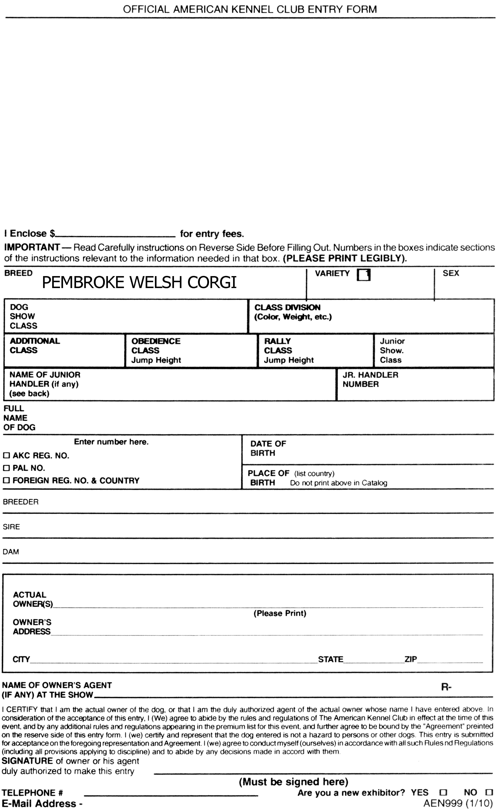

MAYFLOWER PEMBROKE WELSH CORGI CLUB, INC.

Holiday Inn Boxborough, 242 Adams Place, Boxborough, MA 01719

June 15-17, 2016

□ Wed., June 15, 2016 Rally-#2016413008, Altered Dog, Vet. Sweeps

□ Thurs. Conf. #1, Obed. #1- #2016413013

□ Fri. Conf. #2, Obed. #2-#2016413014

ENTRY FEE: $33 for first entry of Regular Classes(Conformation, Rally, Obedience including optional titling); $27.00 for first entry in Non-Regular Classes (Veteran, Brace Unit, Stud Dog/Brood Bitch); $27 for 2nd entry, same dog, Regular or Non-Regular Classes. Puppy Classes (6-9 & 9-12) $27; Sweeps, $27; Junior Show, Free. Altered Dog Classes (Veteran, Performance Titled, Fluffy, Open) $20.00.

CLOSING DATE: for entries 12:00 Noon, Wednesday, June 1, 2016.(at Show Superintendent’s Office) After Which Time Entries Cannot Be Accepted, Cancelled or Substituted except as provided in Chapter 11, Section 6 of the Dog Show Rules.

MAKE ALL ENTRIES with fee to: Jim Rau Dog Shows, LTD., P.O. Box 6898, Reading, PA 19610

MAKE ALL CHECKS and MONEY ORDERS payable to J.R.D.S. LTD.
CANADIAN EXHIBITORS must make fee payable in U.S. FUNDS.

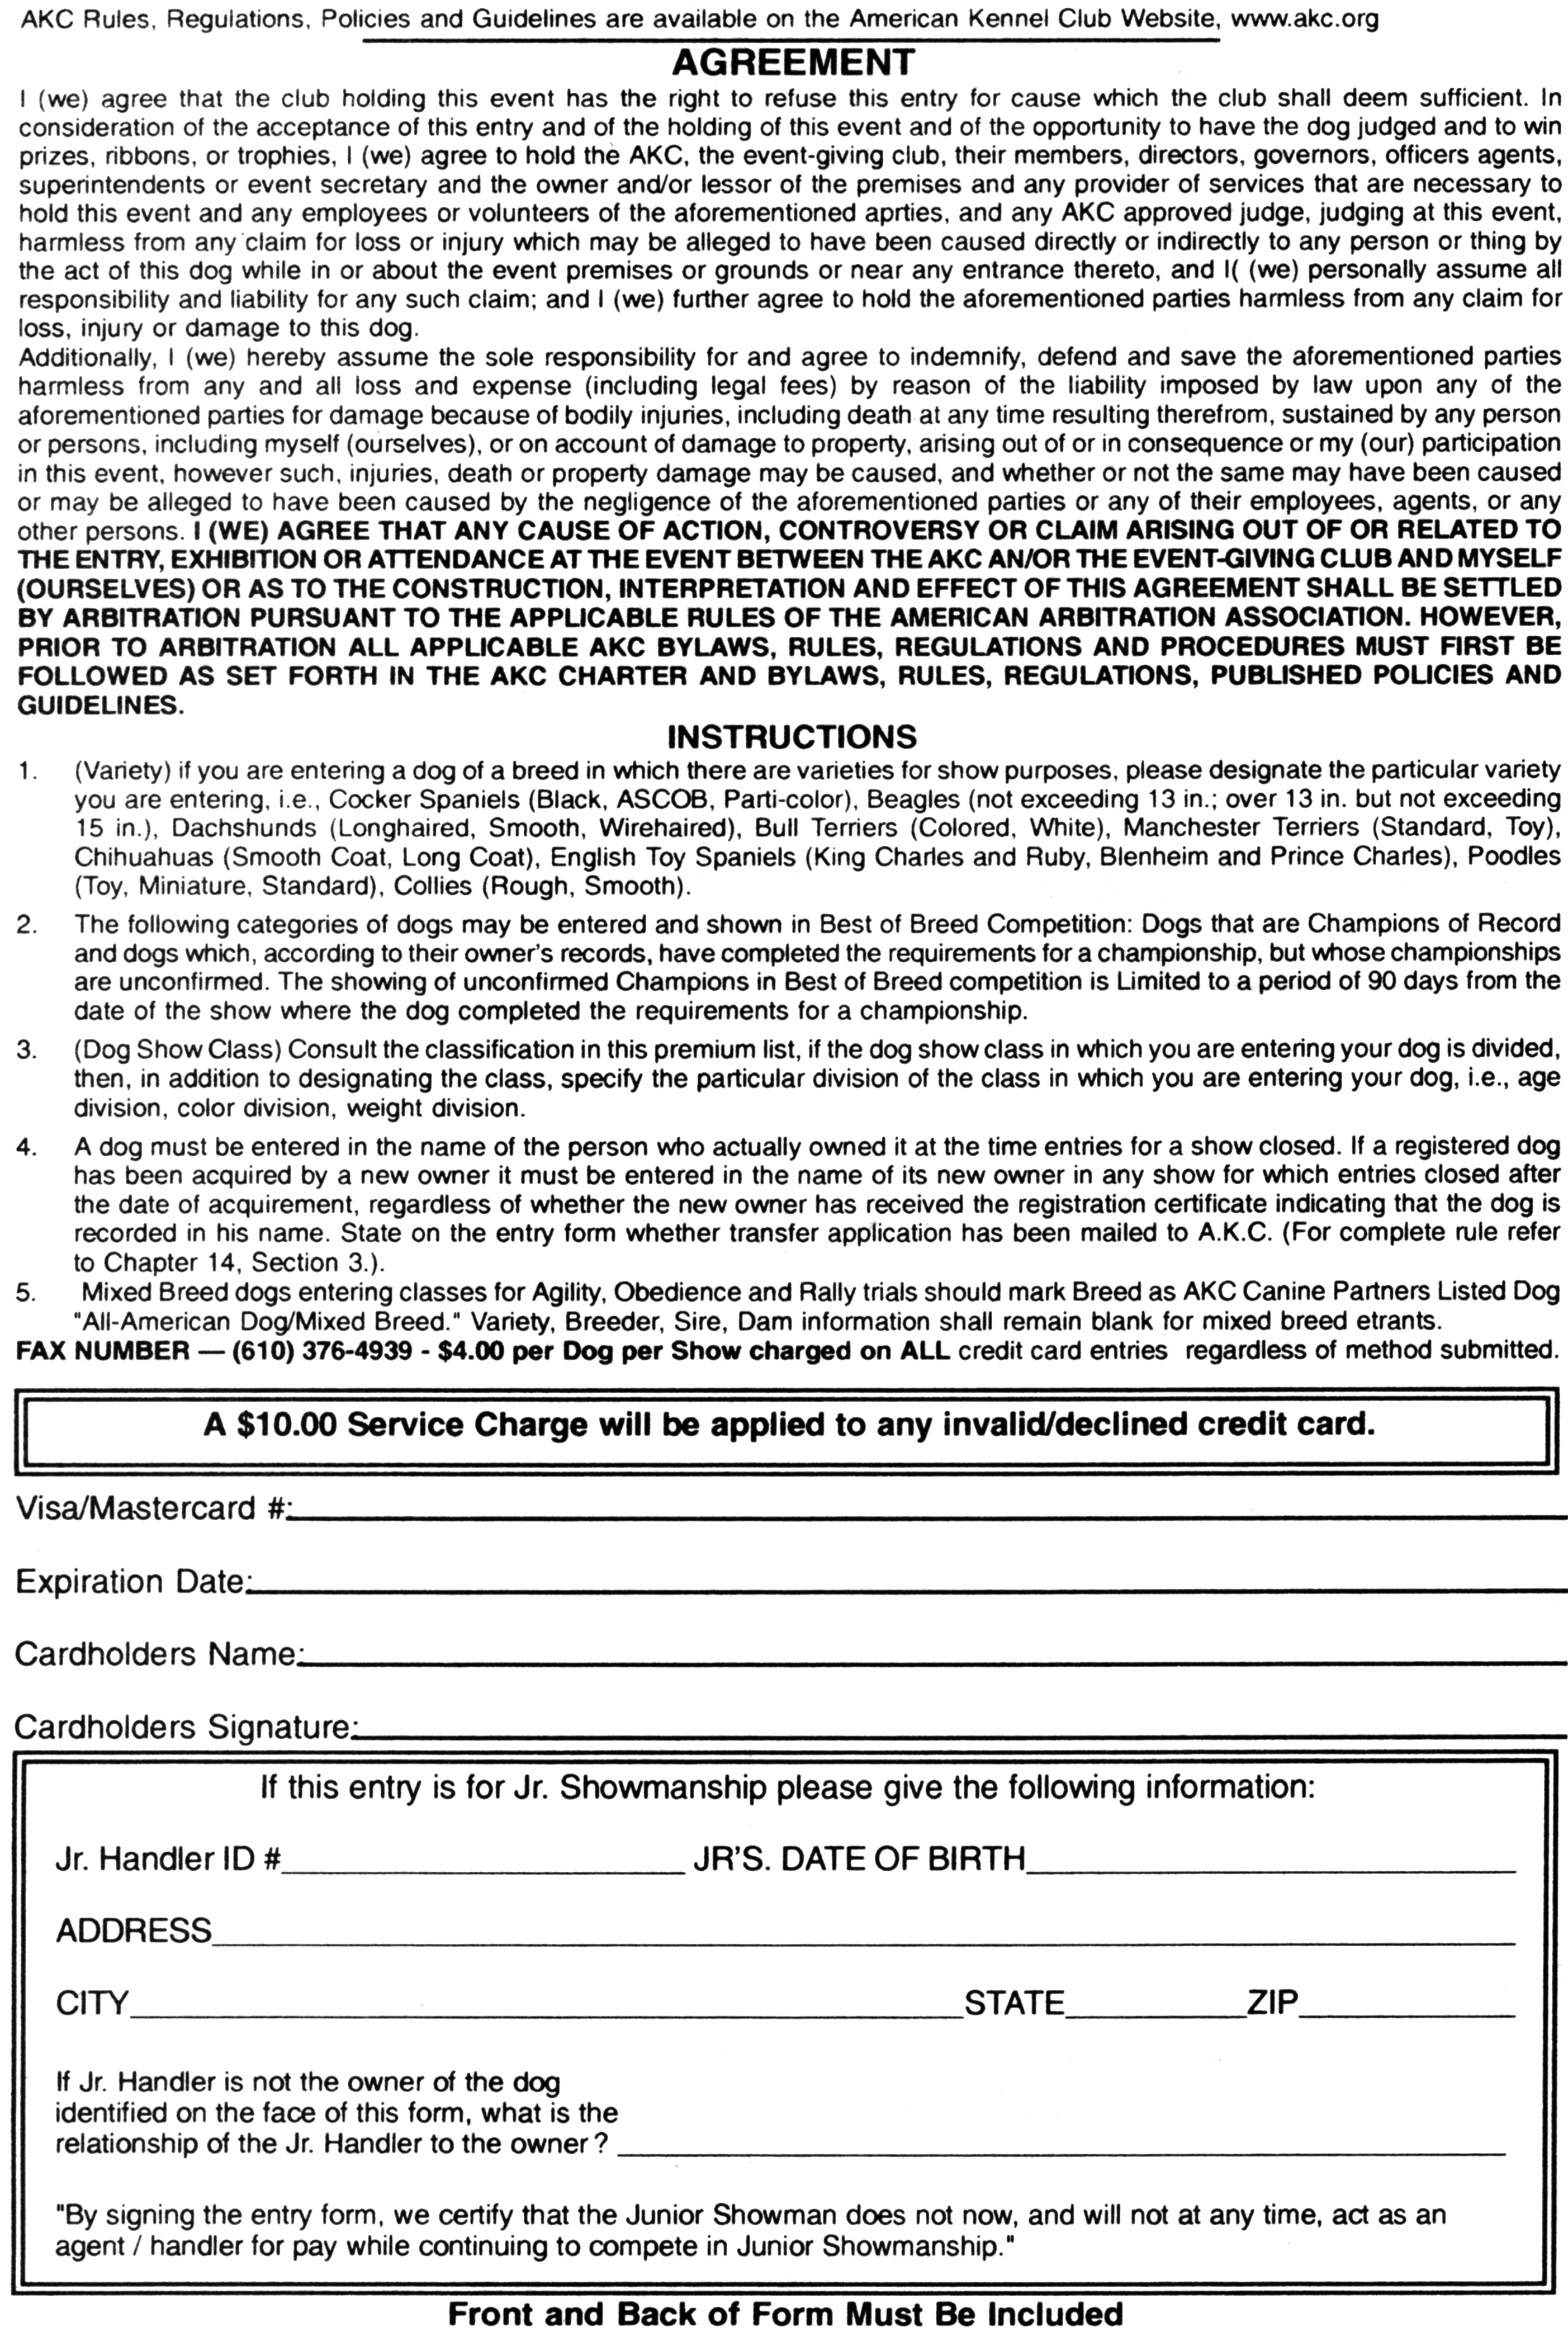

MAYFLOWER PEMBROKE WELSH CORGI CLUB, INC.

Holiday Inn Boxborough, 242 Adams Place, Boxborough, MA 01719

June 15-17, 2016

□ Wed., June 15, 2016 Rally-#2016413008, Altered Dog, Vet. Sweeps

□ Thurs. Conf. #1, Obed. #1- #2016413013

□ Fri. Conf. #2, Obed. #2-#2016413014

ENTRY FEE: $33 for first entry of Regular Classes(Conformation, Rally, Obedience including optional titling); $27.00 for first entry in Non-Regular Classes (Veteran, Brace Unit, Stud Dog/Brood Bitch); $27 for 2nd entry, same dog, Regular or Non-Regular Classes. Puppy Classes (6-9 & 9-12) $27; Sweeps, $27; Junior Show, Free. Altered Dog Classes (Veteran, Performance Titled, Fluffy, Open) $20.00.

CLOSING DATE: for entries 12:00 Noon, Wednesday, June 1, 2016.(at Show Superintendent’s Office) After Which Time Entries Cannot Be Accepted, Cancelled or Substituted except as provided in Chapter 11, Section 6 of the Dog Show Rules.

MAKE ALL ENTRIES with fee to: Jim Rau Dog Shows, LTD., P.O. Box 6898, Reading, PA 19610

MAKE ALL CHECKS and MONEY ORDERS payable to J.R.D.S. LTD.
CANADIAN EXHIBITORS must make fee payable in U.S. FUNDS.

★ NOTICE TO EXHIBITORS ★

ENTRY FEE: $33.00 for the first entry of a dog in regular class in Rally, Obedience or Conformation, except Puppy Classes and Non Regular classes (Veterans,Brace Unit, Stud Dog/Brood Bitch) which are $27.00. Each additional entry of the same dog is $27.00. Sweepstakes - $27.00. Altered Dog $20.00.
CLOSING DATE for entries is 12:00 NOON, Wednesday, June1, 2016 at Show Superintendent’s Office after which time entries cannot be accepted, cancelled, or substituted except as provided for in Chapter 11, Section 6 of the Dog Show Rules.
An AKC RECORDING FEE of $.50 and an AKC Event Service Fee of $3.00 will be required for each dog entered in any Licensed Club Show, Obedience Trial. If a dog is entered in more than one class in one of these events, the AKC Recording Fee and Service Fee is to be collected on the first entry only. (AKC Rules Applying to Dog Show, Chapter 11, Section 2). An AKC Recording Fee of $3.00 will be required for each entry in any Licensed Rally Trial. If a dog is entered in more than one class in a Rally Event, the AKC Recording Fee is to be collected on each of the entries of that dog. (AKC Rally Regulations, Chapter 1, Section 3). All Recording Fees are paid to the American Kennel Club.
RETURNED CHECKS do not constitute a valid entry fee. The Show Secretary will add a $20.00 collection fee to the amount of each returned check. Subsequent returned checks from the same exhibitors may result in their being put on a CASH ONLY basis.
TELEGRAPH, TELEPHONE AND UNSIGNED ENTRIES CANNOT BE ACCEPTED.
ENTRIES NOT ON OFFICIAL AKC ENTRY FORMS AND PHOTOCOPIES OF ENTRY FORMS without the Agreement and Rules on the reverse side of the Official AKC Entry Form are NOT ACCEPTABLE.

MAIL ALL ENTRIES WITH FEES TO Jim Rau Dog Shows, P.O. Box 6898, Reading, PA 19610. Make checks and money orders payable to J.D.R.S. Ltd.
ALL CREDIT CARD ENTRIES, REGARDLESS OF METHOD SUBMITTED, are processed through the Fax program and will be charged a $4.00 per dog show convenience fee.

ENTRIES RECEIVED WITHOUT FEES will not be accepted.
ACKNOWLEDGEMENT OF ENTRIES will be made as soon as practical with tickets and/or identification cards. The person accompanying a dog must show tickets of admission and identification before the dog will be received. SHOULD SUCH ACKNOWLEDGEMENT NOT BE RECEIVED BY THE EXHIBITOR within a reasonable time, please notify Jim Rau Dog Shows, Ltd., Show Superintendent (610) 376-1880.
INTERNATIONAL EXHIBITORS make fees payable in U.S. FUNDS.
NO ENTRY SHALL BE MADE AND NO ENTRY SHALL BE ACCEPTED WHICH SPECIFIES ANY CONDITIONS AS TO ITS ACCEPTANCE.

ENTRY FEES shall not be returned in the event that a dog is absent, disqualified, excused by Veterinarian or Judge, or barred from competition by action of the Show Committee. If because of riots, civil disturbances or other acts beyond the control of the management it is impossible to open or to complete the show, no refund of entry fee will be made.
ERRORS ON ENTRY BLANKS. Owners are responsible for errors in making out entry forms, whoever may make such errors, and no entry fee will be refunded in the event of such errors or cancellation of entries after the published closing date.
NO REFUND FOR DUPLICATE ENTRIES.
CONSULT JUDGING PROGRAM FOR TIME OF JUDGING.
DOGS MAY ARRIVE any time prior to their scheduled time of judging. DOGS NOT REQUIRED for further judging will be excused.

JUDGES WILL NOT WAIT FOR ANY DOG HOLDING UP A CLASS. Owners or agents alone are responsible for the presence of their dogs in the judging ring when their classes are called to be judged. The Show-giving club and the Show Secretary have no obligation or responsibility for providing service through public address system or stewards or runners for the purpose of calling or locating dogs that are not brought into the ring when required.
ALL DOGS PRESENT must be held on leash or confined to their crates except when being judged or when in the exercising ring.
CLASS CASH PRIZES & TROPHIES will be given in the ring to the person showing the dog. Claims for prize money or trophies must be made in the ring before the judging of that breed is over, and the Show Secretary to be advised at once. The Show Secretary and Show-giving Club may disclaim any liability for cash prizes or trophies once the judging of the breed is over. Awards larger than 11x14x2 inches in size will be mailed upon request.
THE SHOW COMMITTEE/SHOW SECRETARY will use due care and diligence for the welfare of dogs and exhibitors, but will not be responsible for, nor assume any liability in the event of, an accident or misfortune to either dogs or exhibitors participating in this show and further assumes no responsibility for injury to children not under the control of their parents or guardians.
CLEAN UP: Exhibitors and handlers are responsible for clean conditions in and around their set-up and at the show site.
NO GASOLINE OR DIESEL GENERATORS are permitted inside any building or within 100 feet of any tent in which this show is conducted.
The Mayflower Pembroke Welsh Corgi Club, Inc. and the Show Superintendent assume no responsibility for any loss, damage, or injury sustained by an exhibitor, agent, and spectator, to any of their dogs or property, and further assume no responsibility for injury to children. The welfare of the child of an exhibitor or spectator is assumed to be the responsibility of that person. It is distinctly understood that exhibitors and spectators will use control and restraint.

RSVP Special Events Form
Please return this form by Wednesday, June 1, 2016 to Susan Gorman.
Please clearly PRINT all requested information.

Name: ____________________________________________________
Address: __________________________________________________
City, State & Zip: ____________________________________________
Phone: (_____) ______-____________
E-mail:____________________________________________________
NOTE: The prices below are for a timely response postmarked before/on June 1, 2015. Responses postmarked after June 1: Welcome Party--$25, Thursday Buffet--$30, Banquet--$45, Grooming--$25, Catalog--$14. These amounts are in parenthesis below.
Item | Cost | Number | Total
Welcome Party – Wednesday evening, June 15 – Cash Bar & Dinner | $20 ($25)
Grooming Space – 2 crates & table, Space is limited and will be re-allocated (based upon the entry) if the space overfills, refunds will be given. | 1-3 spaces  $20 per space  4+ spaces  $I7 per space ($25)
Buffet – Thurs. evening, June 16 - | $25 ($30)
Banquet – Fri. evening | $40 ($45)
Catalog – prepaid  ($14 day of show) | $10
Raffle tickets – please specify raffle item and number of tickets for each item.  ____ Quilt by Barbara Fisher  _____Signed Original artwork and  Giclee “Howling in the Rain”  _____Signed Original artwork and  Giclee “Mary Pawpins”  ____ Beverage and Chocolate  Basket donated by the Show  Committee | 1 Ticket $2.00  6 Tickets $10.00  20 Tickets $15.00
Please note any dietary restrictions or needs  on this form.  Make checks or money orders in US funds payable to MPWCC. Send with this form to: |  | Total
Susan Gorman, 1085 Ferry St., Marshfield, MA 02050.
Reservation Form RV Parking
Holiday Inn Boxborough Woods
242 Adams Place, Boxborough, MA 01719
Phone: (978) 263-8701 Fax: (978) 266-9429

Please indicate below the number of nights you will need your RV reservation for. Prices are a per day charge of $35.00. Fax order with credit card authorization form to
(978) 266-9429 and all payments made by check must be received no later than 7 days prior to Show date. Mail all checks to the address above, attention the Executive Office, payable to Holiday Inn Boxborough.

IF THE FORM OF PAYMENT IS CREDIT CARD, YOU MUST PROVIDE A COPY OF THE FRONT & BACK OF THE CREDIT CARD OR PROVIDE THE SECURITY CODE FOR AUTHORIZATION. THE SECURITY CODE MAY BE WRITTEN BELOW OR CALLED INTO OUR SALES OFFICE.
General Information
Show Name: Mayflower Pembroke Welsh Corgi Club Show Date: June 15-17, 2016

Name
Telephone | ( )
Address
Email address
On Site Contact

RV Parking
#Nights | Arrival/Departure date | Cost per night $30.00 | Total

Credit Card Authorization

Grand Total $____________ Credit Card Type: ________________
Cardholder Name: _______________________
Card #______________________________________ Exp Date__________
CC security code __________

Signature______________________________________________________
Check Amount Enclosed___________________ Check #______________

Versatile Corgi Challenge Entry Form:
Entries close: June 1, 2016
A complete description of eligible classes, rules, scoring can be found on the Mayflower Website: www.mayflowercorgiclub.org.
Dog’s Registered Name:____________________________________________________
AKC/PAL/ILP# _____________________ Date of Birth: ____________
Call Name: _______________________________
Owner: __________________________________________________
Address:__________________________________________________
Email: _____________________________________
Phone:__________________________
My dog is entered in: For each venue, list the class(es) and or level. Abbreviations are OK. For example, Herding PT. For obedience and conformation please designate Trial or Show 1 or 2 or both. See description of altered dog classes in this premium.
Herding________________________________________________
Corgi Only Agility_________________________________________
Rally___________________________________________________
Obedience______________________________________________
Altered Dog ____________________________________________
Jr. Show. _______________________________________________
Conformation ___________________________________________
Entry Fee: $10.00. Entries must be received by June 1, 2016. No credit card entries. Make checks or money orders payable to “MPWCC” in US funds and send with this entry to: Jim Rau Dog Shows, LTD., P.O. Box 6898, Reading, PA 19610
I agree to hold MPWCC harmless for any adverse event or injury that may be incurred at this event. I agree to abide by any and all requirements of noise control and cleanliness of the rooms and areas.

Signature: ______________________________________________________________________

